**Fetch date and temperature from temperature_data where zip code is greater than 300000 and less than 399999.**

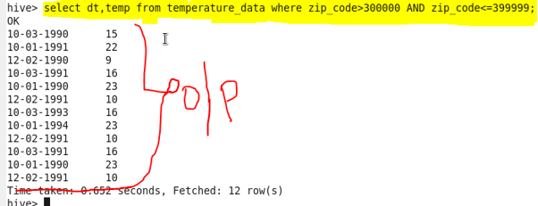

**● Calculate maximum temperature corresponding to every year from temperature_data table.**

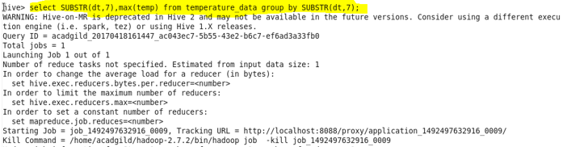

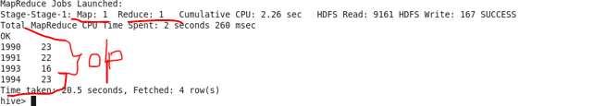

**● Calculate maximum temperature from temperature_data table corresponding to those years which have at least 2 entries in the table.**

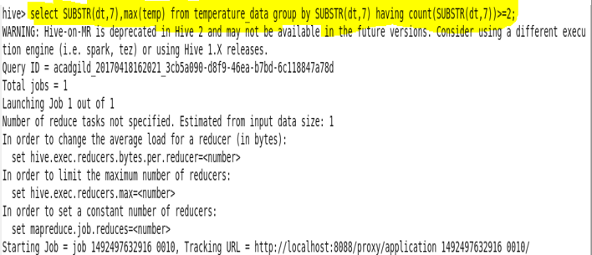

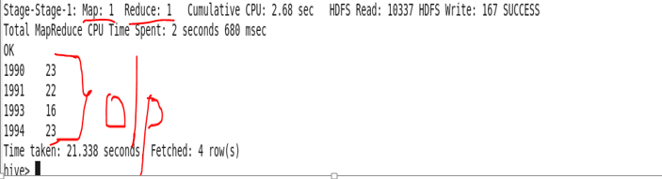

**● Create a view on the top of last query, name it temperature_data_vw.**

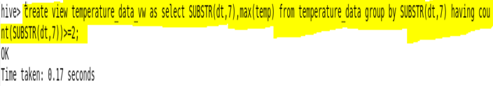

**● Export contents from temperature_data_vw to a file in local file system, such that each file is '|' delimited.**

